
Lebanese American University
Department of Computer Science and Mathematics
Computer Networks-

Project

Instructor:
Dr. Ayman Tajeddine

Team Members:
Mohammad Shouaib (202208425)
IP: 10.1.1.224
Mac: E4-A8-DF-A8-D3-4E

Things that I used at some steps:
Logging: Used SQLite to log requests, response and filters (blacklist, whitelist)
Why SQLite:
Lightweight: No setup or server management is needed; the database is stored in a single file.
Fast for Small-Scale Use: It’s efficient for applications with moderate amounts of data.
Easy to Use: No external dependencies; it integrates seamlessly into Python applications.
Local Development: Ideal for small to medium-scale proxy servers that don’t need the complexity of larger databases like PostgreSQL or MySQL.
Caching:
I was between 2 options to either use a dictionary to save Response, and timestamp (having key as host + URL), or using a file.
And I implemented both.
Dictionary VS File Cache
Feature | Dictionary Cache | File Cache
Speed | Very fast (in-memory) | Slower (disk I/O dependent)
Persistence | Non-persistent (RAM only) | Persistent (survives restarts)
Capacity | Limited by available RAM | Limited by disk size
Scalability | Challenging for large datasets | Easier to scale storage
Implementation | Simple | Requires more logic for management
Concurrency | Easier to manage | Requires handling file locks
Use Case | Small, frequently accessed data | Large, infrequently accessed data

Best approach would be implementing both and using a hybrid solution having:
- Dictionary Cache: For frequently accessed or hot data (e.g., results of recent API calls).
- File Cache: For larger, less frequently accessed data, falling back to the disk if the data is not in memory.

Features/Properties of the Design
- Thread Pool for Scalability: The ThreadPoolExecutor enables the proxy to handle multiple requests concurrently without overwhelming the system.
- Modular Design: Independent modules (Logs, Filter, Cache, and Parse) for logging, filtering, caching, and parsing ensure clean separation of concerns and extensibility.
- Non-blocking Client Communication: The use of non-blocking sockets (setblocking(False)) ensures that the proxy can handle partially sent requests without stalling.
- Request Logging: Detailed logging of request and response data for debugging, analytics, or compliance purposes.
- Custom Header Modification: Adjusts HTTP headers to conform to proxy requirements and maintain compatibility with target servers.
- Dynamic Filtering: Filters requests based on hostname and connection details for enhanced security (blacklist, whitelist).
- Cache Integration: Improves performance for frequently accessed resources by serving cached responses when available by having 2 approaches available using dictionary or file cache.

Challenges faced
- Concurrency Handling: Ensuring proper synchronization and thread safety while using multithreading to avoid race conditions.
- Non-blocking I/O: Introducing non-blocking sockets for scalability, handling edge cases like partial reads, and ensuring all data is read correctly.
- Error Handling: Managing unexpected client behavior (e.g., malformed requests, dropped connections) without crashing the server.
- Performance Optimization: Balancing the size of the thread pool (MAX_THREADS) and ensuring the thread pool doesn't become a bottleneck during high traffic.
- Integrating Filtering and Caching: Coordinating between Filter and Cache modules without blocking or introducing delays.

Explanation of code.

First, after execution, the code will initialize the database, and then start the proxy server
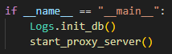

In the init_db function, the below happens:
Enabling WAL mode.
Executing queries for creation each table.
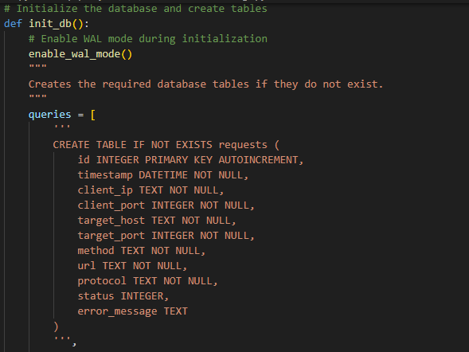
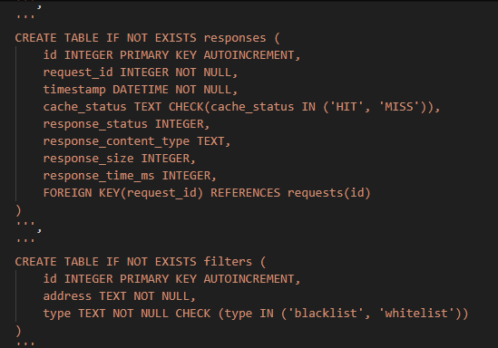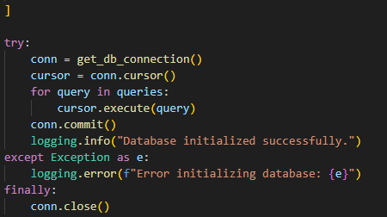

After some syncronise problems, I created the below:
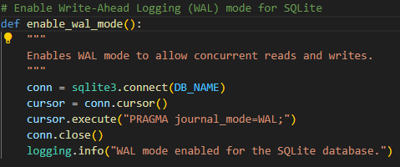
Enabling WAL mode ensures that writers don’t block readers, even for long-running queries.
All of the above along with couple more functions below will using this function (DB_NAME=’proxy_logs.db’):
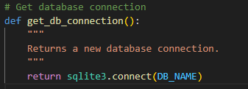

After finishing initializing the database, the proxy will start:
The proxy server will be bind to ‘127.0.0.1’, and port=8081. It will be capable of accepting 32 simultaneous connections (why 32? After some research, since my pc has 8 threads, then 8*4 will be the best number of simultaneous connections). And lastly, this server will keep on listening for incoming requests, and handling them using threads.
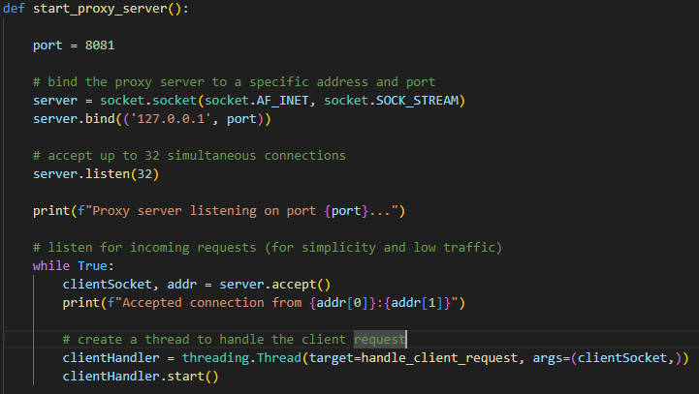
The other approach of multi-threading (best for high traffic)
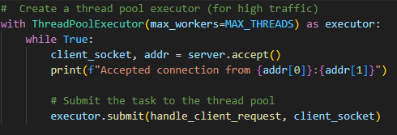
Now let’s see what happens in handling the client request:
First, the code will extract both client port and ip for logging purposes. Then will be using setblocking(False) to ensure that the proxy can handle partially sent requests without stalling. Then will be receiving from the client the request as chunks of 1024. In the process, will be appending the request to parse it later on, and redirect it. (exception handling was used, and data was being checked if null to ensure smooth running of the server).
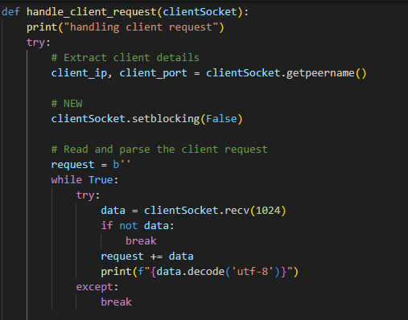

Then the code will be handling the extracting, parsing, and modifying the request:
Will first extract method, url and protocol for logging purposes.
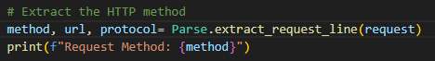
According to the below Request image example, we can see that in the HTTP request line, we have the method in green, the url in gray, and the protocol/version in yellow.
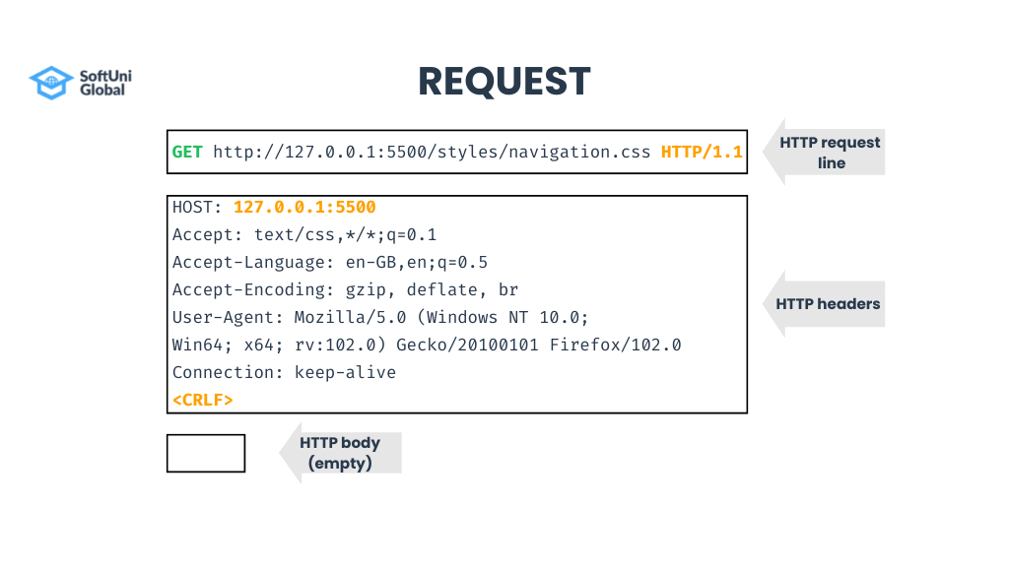
So, first the code will decode the request, then ensures that there are no errors using exception handling and validation of not null or missing request. And at last will get the request line info.
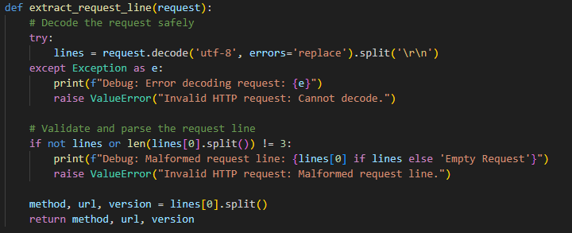

Then will extract target server address and port.
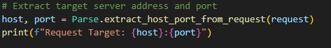
Also according to the request seen above, there is a line that starts with Host:…
So the code will see if there is a match and if it exists. If so, it will extract host and port. But if port is null, it will manually set port number to 80. And if no match, the exception will be handled.
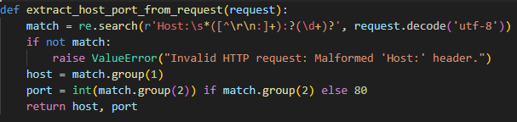

After that, the code will modify the request header with what is necessary.
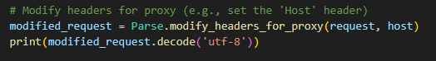

In the below function, first the request will be decoded, and then split into 2 main parts. The header and the body.
Then will iterate over each line in the header and search if the line that starts with “Host:” will update the host to make sure its present correctly and valid. Else if the line is related to the proxy server, then remove/ignore it. Else the line will be added to the newly modified header.
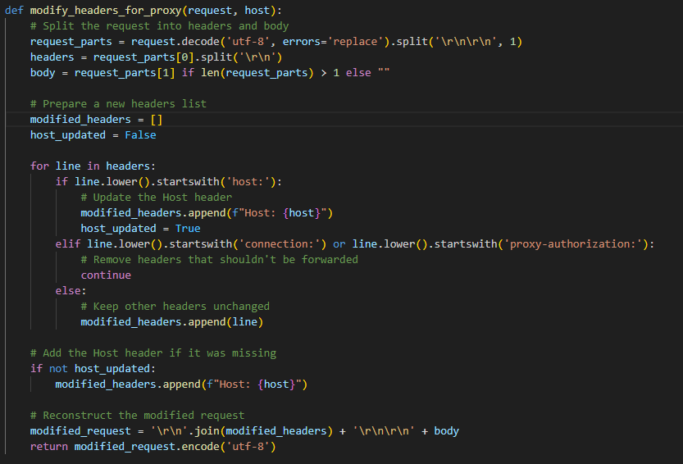

Then will be logging the request received from client as a server.
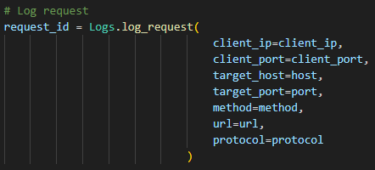

In the log request function, the code will execute the insert query into the database. After executing the query, some logs will be printed to assure that the process went smoothly or that an error occurred.
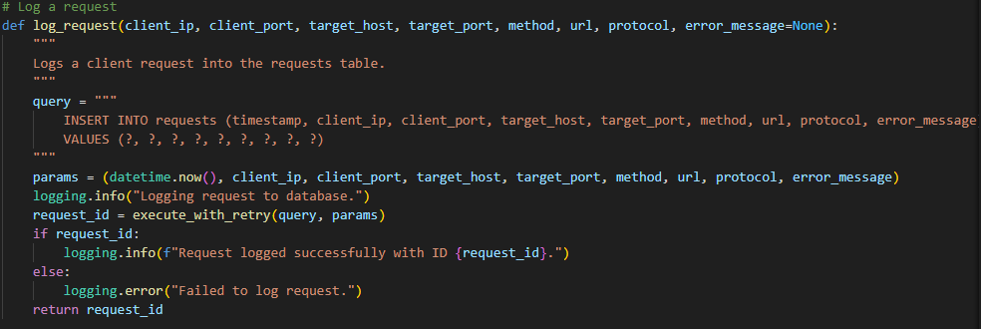

Now that the request has been modified and is ready to be rerouted to host. The code will need to check if this filter is accepted or not. Because if not it will send a forbidden response.
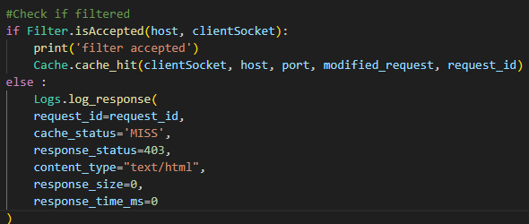
If its whitelisted, and not blacklisted. It will be accepted.
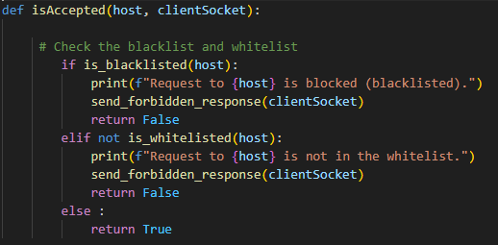

The is blacklisted and is whitelisted functions will select the type of filtering we want along with the host, and then see if there exists such filtering.
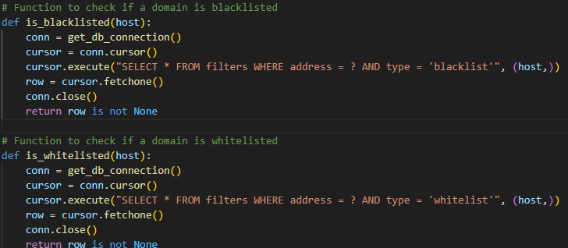

The forbidden response:
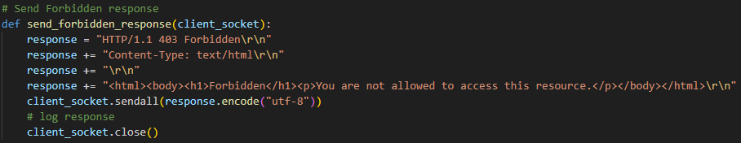

Now if accepted, will see if its cached or not.
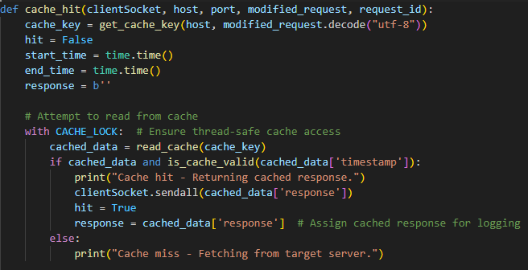
Will create the cache key, and initialize some variables.
Then see if the cache is locked by other threads (synchronization). Then will read from cache and will see if the cached-data exists (already cached), then will check if its still valid. If so, will directly send the cached response. Else will request the response from the server.
If miss, will create a new socket to communicate with server, will then send all the ‘modified request’ to the server. When done, the code will start timer to log it with response, will then listen for the response as chunks of size=1024. And will be directly sending the received data to the initial client. If any error occurs, the client socket will close its connection for the thread and not for the whole socket. And the destination socket will be closed because we are done with it.
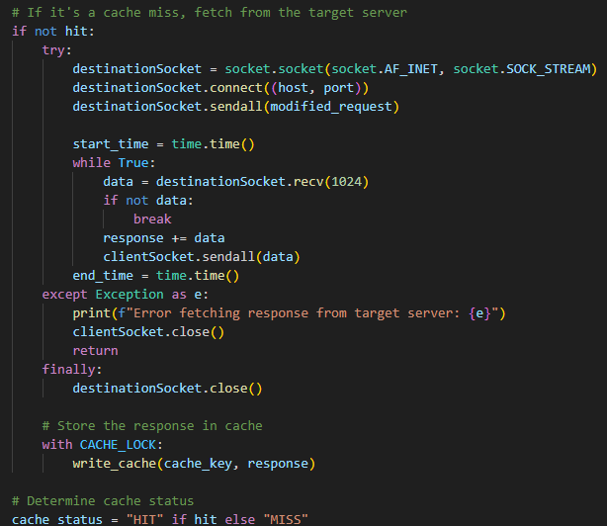
When done with the response, its time to cache the response, and log it.
To have proper response logging, some parsing and extraction of info was done.
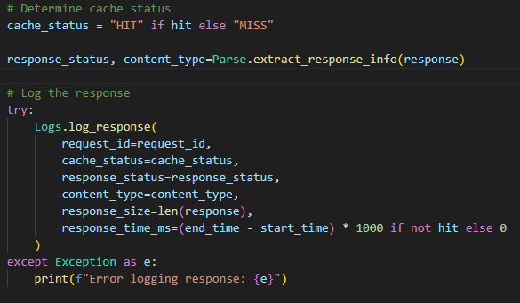

First, the code will get the header part from the response, and extract the response status from it. Then, it will search for the line that starts with ‘Content-Type:’ to extract the content type.
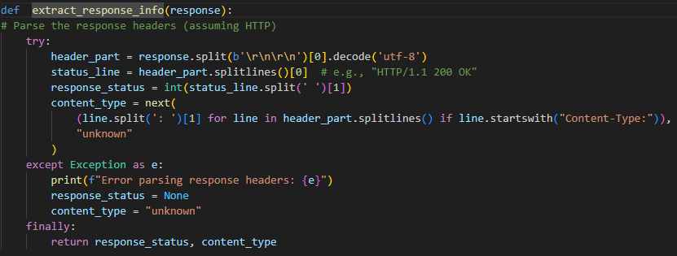

Now regarding the response logging, it follows the same principle as the request logging.
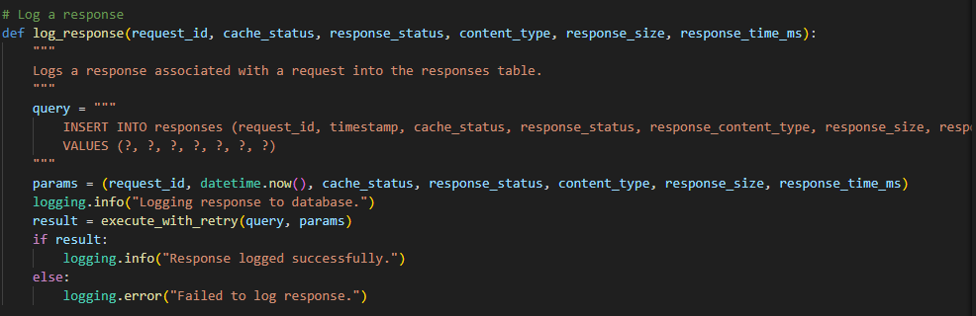
In both request and response logging, an execute_with_retry() function was used after encountering some sync problems because of multi-threading.
What this will do is that each thread will have a number of retires to try running its query in case another thread was modifying the database (locked). And as long as the database is locked, a small sleep will be made so that the thread accessing the database could finish its work.
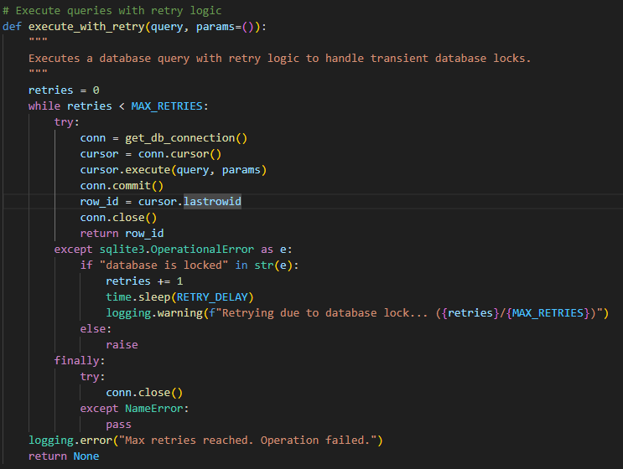

Now to go back to the handle_client_request, incase an exception is thrown, appropriate logging will be done. And finally, we will close the thread socket.
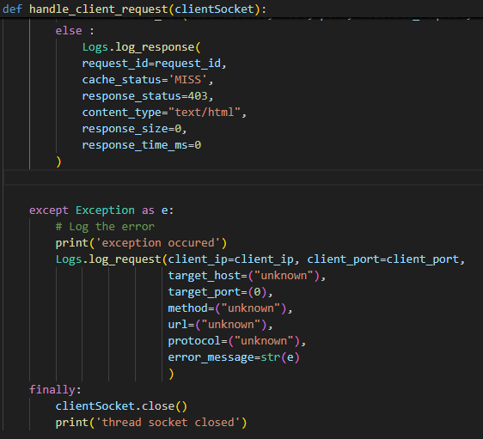

Execution:
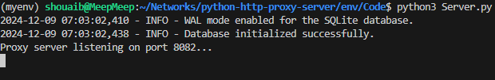
Tables were successfully created.
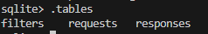

Testing using Client.py code
Simple code that has a test_request, will send this request and print its response.
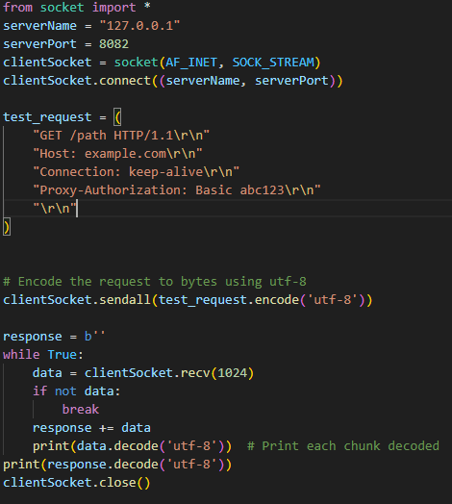

The client will connect:

As we can see, the server accepted the connection, and started handling the client request.
We can see that the request got rejected as it was not accepted by the filter (not white listed)
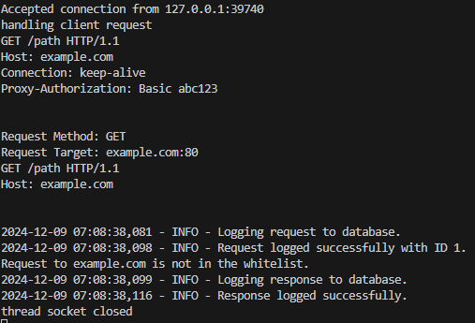
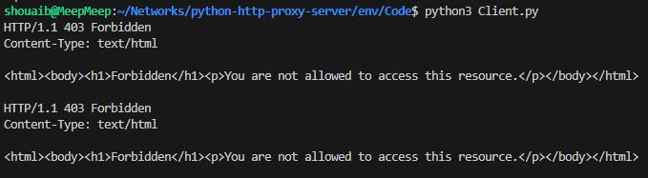

Now lets try adding this host ‘example.com’ to black list:
Same thing happens but different logging (blacklisted).
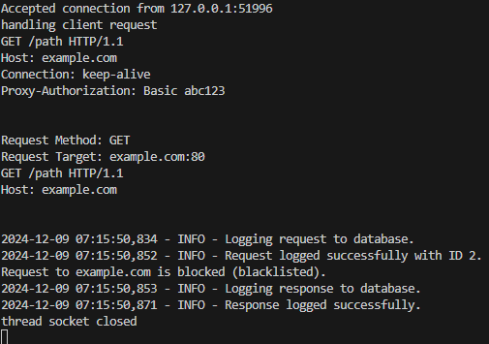
Now lets try adding it to whitelist.
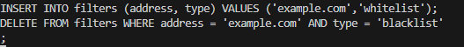
Changed client connection to close and not keep alive. The request took forever to timeout.
Filter accepted 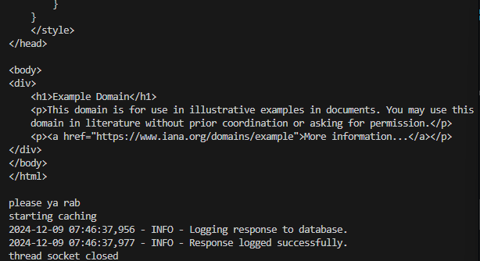

Response returned to command line
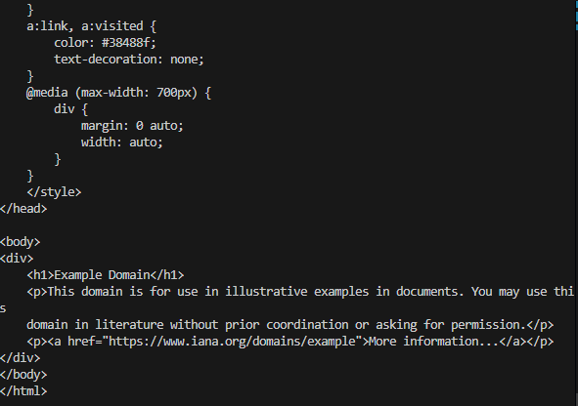
Resending same request cache hit:
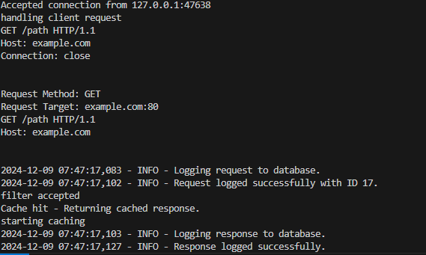
Present in cache:
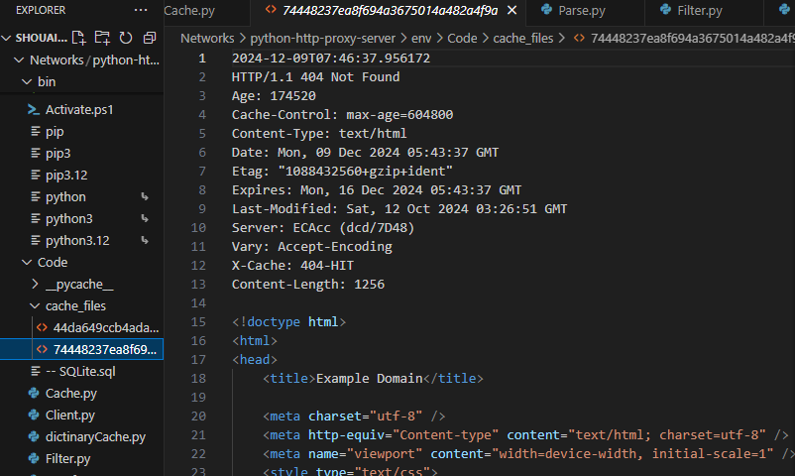

Requests schema logs (had some issues so had to debug and change the request):
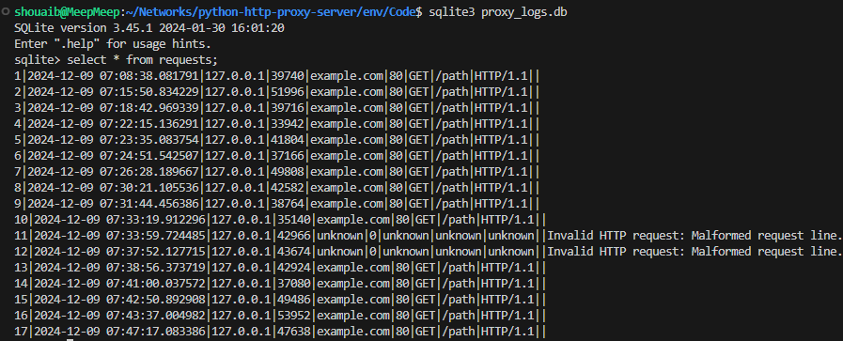
First 2 responses got an error and we can see the last 2 params are zeros.
While the last 2 responses were successful both having hit and miss.
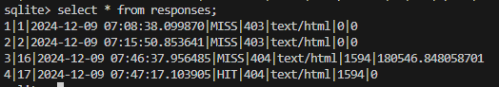

Interface:
